the new york city department of education

DAVID C. BANKS, *Chancellor* Community School District #13

*Ronald Edmonds Learning Center, MS 113* RICHARD GADSBY, *Principal IA*

*300 Adelphi Street, Brooklyn, NY 11205*  ALISON BEST-ADAMS, *Assistant Principal, IA*

*Telephone: (718) 834-6734 / 6735 / 6779*

*Fax: 718 596-2802*

*Website: http://www.relc113bk.org*

RELC Student Cellphone Policy

All schools are required to establish a school-based policy regarding cell phones and electronic devices each year as per Chancellor’s Regulation A-413

Cell phones, computing devices, portable music devices, smart watches, air pods, bluetooth headphones and entertainment and gaming systems may not be turned on or used while on school property and must be kept away and not seen are not to be used during school hours, 8:10a to 2:30p and during afterschool programming, 2:30-5:45p. Every student will be assigned a personal Yondr Pouch with a specific number, similar to being assigned a textbook. While the Yondr Pouch is considered school property, it is each student’s responsibility to bring their pouch with them to school every day.

In case of an emergency, we direct our students to safety first. School staff will be able to unlock a Yondr pouch in a matter of seconds for students once they are in a safe and secure location. If you have an emergency and need to reach your child, you can call the main office at 718.834.6734.

Process

Building Entrance: As students enter the building, they will:

1. Turn their phone off.
2. Unlock their empty Yondr Pouch using an Unlocking Base at the Building Entrance(s).
3. Place their phone and any other electronics inside the pouch, securely close it and store it in their backpack.
4. Late students will follow the above procedures in front of a staff member of a member of the main office.

Each student will maintain possession of their cellphone inside their Yondr Pouch for the duration of the school day.

Building Exit: As students exit the building at the end of the school day or at the end of afterschool, they will:

1. Unlock their pouch using an Unlocking Base at a Building Exit(s).
2. Remove their phone from their pouch.
3. Securely close their empty pouch and place it in their backpack for the next day.

Exception: If a student is picked up early by parent/guardian, the student will unlock their pouch at the main office

Below is a list of potential student violations and the consequence.

|  |  |
| --- | --- |
| VIOLATION | CONSEQUENCE |
|  |  |
| If a student forgets their Pouch – comes to school without their pouch. | 1. Student’s phone will be labeled and locked in the main office. 2. School staff confiscates cell phone during arrival, places the cell phone in a marked envelope and returns the cell phone to the student after the conclusion of student dismissal 3. School staff speaks to student, reviews expectation of the Yondr program 4. Student can pick up at the end of the school day. |
| Lost or Damaged Pouch  Physical damage to the pouch in an attempt to circumvent its intended purpose. (Ex: Discoloration, pen marks, bent pin or stripped lock inside the pouch) | The student will be allowed to bring a phone back to school if they or their parent/guardian pay a $10 fee to replace the damaged school property, If a child bring a cell phone without payment, the phone will be labeled and locked in the main office for parent/guardian to pick up after the 2nd time. |
| If a student uses their phone during school hours | 1st time:   * The phone will be labeled, locked in the main office and the parent will be notified and students can pick the phone at the conclusion of the school day (2:30p).   Each time after the 1st time:   * The phone will be labeled, locked in the main office and the parent will be notified and parent/guardian MUST pick up the phone. |
| Lying to school personnel about placing the device in the pouch | 1. The phone is confiscated by the teacher or the teacher alerts the Dean or administration. 2. School-based investigation begins for B16 by Dean 3. Phone and replacement pouch are confiscated for the duration of the school day 4. Parent outreach is made by Dean, school counselor or other school staff. 5. School issues disciplinary response for B16 based upon the findings of the investigation |
| Repeat violation(s) of any of the violations described above | 1. Phone is confiscated and placed in an envelope; Parent Conference with Dean and/or grade-level AP- phone is returned to the PARENT when parent comes in 2. School issues further disciplinary response as per the Citywide Behavior Expectations - Chancellor’s Regulations 3. Students will lose the right to participate in school trips and other school-related activities. |

How Yondr Works

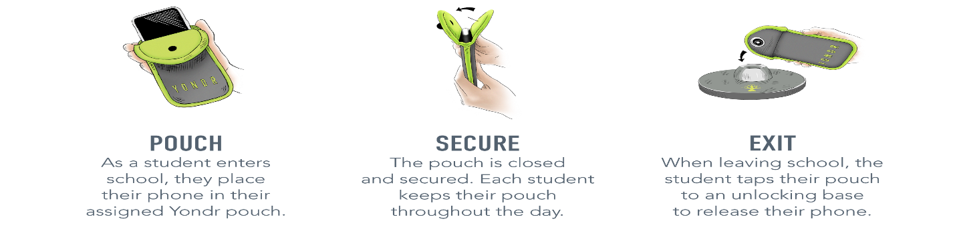

Frequently Asked Questions

What if I want to reach my child during the school day?

We want our students to be engaged in their learning. Please refrain from contacting your student during the school day unless it is an emergency. Contact the main office at 718.834.6734 to reach your child.

What if there is an emergency?

In case of an emergency, we direct our students to safety first. School staff will be able to unlock a Yondr pouch in a matter of seconds for students once they are in a safe and secure location.

Will my student’s phone be safe?

Students are in possession of their phone - in their Yondr pouch - for the entire school day. We will advise students to store the pouch in their backpacks where it is completely safe.

What if the Yondr pouch gets lost/ damaged?

The Yondr pouch is property of RELC. If a student loses, damages or tampers with a Yondr pouch, they will be held responsible. The student’s phone will be confiscated by the school until a parent/guardian comes to the school to pick up their child’s phone and the student will only be allowed to bring a phone back to school if they or their parent/guardian pay a $10 fee to replace the damaged or lost school property. At the end of each school year, every student must return their assigned pouch. If the student does not have their assigned pouch, there is will a $10 fee to replace the school property.

Note: Damage consists of any signs that the physical integrity of the pouch has been compromised, whether intentional or unintentional, as determined by the school or Yondr staff.

How can I clean my student’s Yondr pouch?

In adherence to CDC guidelines, Yondr pouches can be washed in cold water for a short cycle and dried on a short cycle and/or air dried. Pouches can also be cleaned with a disinfectant cleaner.

RELC Student Cellphone Policy

Please Sign and Return to School

As the Parent/Guardian, I affirm that my child, ______________________________________

(Print Name)

____ DOES bring a cellphone to school for safety/parent communication.

____ DOES NOT bring a cellphone to the school building.

Parent Signature: _____________________________________